**Summer Internship Project Report**

**On**

**“Python for Finance: Investment Fundamentals & Data Analytics”**

**Submitted for the partial fulfillment towards the award of the degree in Master of Business Administration of Dr. A.P.J Abdul Kalam Technical University, Lucknow**

**Submitted by:**

**SHIVAM**

**ROLL NO: 2101330700158**

**Batch: MBA 2021-23**

**Under the supervision of**

**Mr. Ajay Gangele**



**School of Management**

**Noida Institute of Engineering and Technology (NIET)**

**(AN AUTONOMOUS INSTITUTE)**

**Affiliated to DR. A.P.J. Abdul Kalam Technical University, U.P, Lucknow, Plot No .19 Knowledge Park II, Greater Noida, Gautam Buddha Nagar, (UP), India 201306**

**DECLARATION**

I **Shivam** hereby declare that project entitled **“Python for Finance: Investments Fundamentals & Data Analytics”** isa record of original work done by me. The findings and conclusions of this project report are based on my study and experience and are conducted under the guidance of Mr. Ajay Gangele.

I also declare that this project is result of my effort and the report is submitted in partial fulfilment of the requirements of MBA program of Noida Institute of Engineering and Technology, Greater Noida and it is not being submitted to any other institution for award of a degree or any personal favour. All details stated above and analysis provided in the report are and hold the best of my knowledge and belief.

**Shivam**

**(MBA 3rd SEM)**

**(Signature of the Student)**

**ACKNOWLEDGMENT**

I take this opportunity to express my gratitude to everyone who supported me throughout the course of the Internship at Indev Consultancy Pvt. Limited. I am thankful for their valuable guidance, constructive criticism, and friendly advice during the project work. I am sincerely grateful to them for sharing their truthful and illuminating views on several issues related to the study.

I gratefully acknowledge my indebtedness to my mentor Mr. Ajay Gangele for his meticulous guidance and support throughout the study.

I express my sincere thanks to Mr. Kedar Dash Managing Director of Indev Consultancy Pvt. Ltd. for providing me with valuable insights and required facilities to successfully complete my study. Their support and guidance at Indev Consultancy Pvt. Ltd. helped me understand and learn how Data Analytics has a long way in the coming years.

I deeply thank my family and dear friends for their cooperation and support.

**Name: - Shivam**

**Reg. No: 0211MBA182**

Contents

1. Introduction of the topic 5

1.1 Introduction 5

Python 7

Finance 13

Measure a Security Risk 14

Measure Co-variance of security 15

Measure the Correlation Between Stocks 15

Markowitz Portfolio Theory 16

Capital Asset Pricing Model 19

1.2 Objective of the study 20

1.3 Need and scope of the family 21

1.4 Limitations of the study 22

2. Company profile 23

OUR USP 25

Capability statement 26

2.1 History of the company 27

some of our partners 27

3. Research methodology 30

3.1 Research Design 30

3.2 Statistical tool used 30

Numpy 31

Pandas 31

Matplotlib 32

4. Data analysis and interpretation 33

Calculate a security’s rate of return in python – Simple Return 33

Calculating a security’s rate of return in python – Logarithmic Return 36

Calculate the Indices Rate of Return 38

Obtain the Efficient Frontier 40

Calculate Beta and Expected return of a Stock (CAPM) 44

Estimate the Sharpe Ratio and verifying how good a portfolio manager is doing 45

5. Conclusion 47

5.1 Findings 48

5.2 Bibliography 49

# 1. Introduction of the topic

## 1.1 Introduction

We all have to deal with certain tasks in our daily lives. Many we can solve on our own, while others, especially the ones that are more complicated, can be solved with the help of a computer. Assume you have defined a problem that must be solved and you know the steps that must be taken to solve it. Even if you could structure your logic perfectly and type a brilliant solution in English, the computer will not understand it as it understands zeros and ones only. No other symbols are similar to a light switch. It recognizes two phases on and off.

To communicate a real-life problem to the computer, you need to create a specific type of text called a source code or a human-readable code that software can read and then process to the computer in zeros and ones.

A program is a sequence of instructions that designate how to execute a computation. Therefore, the formal definition of programming is the following taking a task and writing it down in a programming language that the computer can understand and execute. You need not be a geek or computer scientist to program. Actually, the subject of computer science is not the study of programming. These are different things, and this can confuse beginners.

Computer science is about understanding what computers can do. Programming instead is the activity of telling computers to do something for us. Think about the world we live in today. There are more than a thousand programming languages out there, and each language is designed for carrying out specific tasks. So depending on the sphere to which your problem applies, only some languages can be of good use. For instance, PHP is good for web programming but is not suitable for programming devices. C++ can definitely help you with the latter. While Python and R are some of the favorite tools of data scientists and people from the finance industry. When you meet an experienced programmer, don't think he can program in all languages out there. Instead, it is likely he can work with one or maybe a few languages. But he has mastered them well. But how does somebody become good at programming? First, programming requires problem solving skills and involves abstract thinking. You are supposed to understand your task perfectly and then break it down into a sequence of instructions or smaller computational steps that the computer can execute.

For example, John is asked by his boss to do the following create a program that adds ten to any number his boss inputs with the keyboard. The correct reasoning would be if X is the unknown provided we need an output of x plus ten. After you have created these steps with the help of a programming language, you will type in beautifully organized lines of code.

So the second crucial thing to develop is mechanistic thinking. Unfortunately, computers can only execute what you ask them to do, and they won't understand what you imply by the instructions you have provided. They will simply compute the code without interpreting your output. Fortunately, we can do that though.

Humans can understand and interpret code instructions and adjust it whenever necessary.

And this is why a solid knowledge about the syntax of a programming language and the ability to understand computer code is of paramount importance. It will positively affect your thinking process, allowing you to break down your problem into parts the computer can execute.

In the example we provided above, John must think of the following subtasks. First, he must define a function that takes X as an argument and then returns as an output a new variable equal to x plus ten. This is how this problem can be solved. Regardless of the problem you are facing or the programming language you are using, your coding style is crucial. Remember that having three lines of code is straightforward to understand. However, in practice, you will likely work with hundreds of lines of code that must be sent to other

people. If your work is difficult to read, unnecessarily complicated full of variables, and names conveying no meaning, it will be poorly received by other programmers. Therefore, throughout this course, we will pay attention to the best practices that will help you

organize your code.

Programming challenges are great as they develop your mechanistic thinking and problem-solving abilities. This involves formulating problems, breaking them down into meaningful steps and communicating these steps to the computer in an organized way.

### Python

#### Data Types In Python

**What is Data type?**

In computer science and computer programming, a data type or simply type is an attribute of data which tells the compiler or interpreter how the programmer intends to use the data. or in more simpler terms , Data Type tells what **type of Data** it is.

**Variables and Data Types:**

Variables can hold values, and every value has a data-type. Python is a dynamically typed language; hence we do not need to define the type of the variable while declaring it.

A variable can hold different types of values. For example, a person's name must be stored as a string whereas its id must be stored as an integer.

Python provides various standard data types that define the storage method on each of them. The data types defined in Python are given below.

**Standard Data Types:**

* Numbers: Integer(int), Float(float)
* Strings (str)
* Boolean (bool)
* Tuples (tuple)
* Lists (list)
* Sets (set)
* Dictionary (dict)

#### Variables In Python

**What are Variables?**

Variables are a container that store temporary values or information in computer memory. To use a variable in program, you must declare a variable.

**What do we mean by declaring a Variable in python?**

In Python, the moment we store any information or value in a variable, variable is declared. We can use variables in program once we declare them or store a value in them. There are two most important entity to declare a variable: a. Variable name b. Value

For Example : age = 10, Here 10 is a value stored in variable named age. This is how we declare a Variable in Python.

age = 10

print(age)

10

#### Operators In Python

**What are Operators?**

Operators are symbols, that are used to perform operations on Operands (**Variables** and **Values.**) There are variety of Operators which are as follows:

* Arithmetic operators
* Assignment operators
* Comparison Operators
* Logical Operators

#### User Input In Python

**What is input() function?**

input() function is used to get input from the user. It takes input from the user and then it converts it into a string.

company = input("Please Enter the Company name:")

#### Type Casting In Python

**What is Type-Casting?**

Type Casting is the method to convert the variable data type into a certain data type in order to the operation required to be performed by users.

In more simple terms, type casting means converting operand's data type to another data type.

**Functions used for Type-Casting**

There are 4 important Functions used for Data Type Conversion:

* int() - int() converts any data type to integer data type.
* float() - float() converts any data to float data type.
* str() - str() converts any data type to string data type
* bool() - bool() converts any data type to boolean data type

#### Strings In Python

**What is String?**

Python string is the collection or sequence of the characters surrounded by single quotes(' '), double quotes(" "), or triple quotes(''' '''), (""" """).

In simpler terms, whatever you write between these quotes are String.

Company = "Console Flare"

member = '500'

year = '''4'''

Sector = """IT"""

print("Data type of company: ",type(Company))

print("Data type of member: ",type(member))

print("Data type of year: ",type(year))

print("Data type of sector: ",type(Sector))

#### Conditional Statements In Python

**What are Conditional Statements?**

We have often used conditional statements in our daily life, such as :

**if** *it rains* ,i will go to office.

number = int(input("Enter the number:"))

if(number%2==0):

print(f'{number} is an even number')

print(f'{number} is not an odd number')

print("Program ended")

#### Lists In Python

**What is List?**

A list can be defined as a collection of **values** or **items** of different Data types.

In more simpler terms, List is a collection of items enclosed between Square brackets []. Unlike other data types like Integer , Float and boolean, List stores multiple values in a single variable.

For Example:

varlist = [1,2,3,4,5,6,7,8,9]

print(varlist)

[1, 2, 3, 4, 5, 6, 7, 8, 9]

#### Sets

**What are sets?**

A Python set is the collection of unordered items. Each element in the set must be unique, immutable, and the sets remove the duplicate elements. Sets are mutable which means we can modify it after its creation.

Properties: Unordered , Mutable\Changeable , Does not allow Duplicate Values.

Sets are unordered and its item has no index numbers. It means Index numbers do not exist in Sets.

Set items are defined in enclosed curly braces {}.

For Example:

varset = {"Console","Python","data","Flare"}

print(varset)

{'data', 'Python', 'Console', 'Flare'}

#### Tuples In Python

**What is Tuples?**

Tuples are used to store multiple items in a single variable. It is also iterable.

In simpler terms, Tuple is a collection of items enclosed between Parentheses ().

Properties: Ordered, immutable(unchangeable), Allow Duplicate Values.

For Example:

name = ('Mark','Bill','Elon')

print(name)

#### Dictionary In Python

**What is Dictionary?**

Python Dictionary is used to store the data in a key-value pair format. The dictionary is the data type in Python, which can simulate the real-life data arrangement where some specific value exists for some particular key. It is the mutable data-structure. The dictionary is defined into element Keys and values.

* Keys must be an immutable element.
* Value can be any type such as list, tuple, integer, etc.

In other words, we can say that a dictionary is the collection of key-value pairs where the value can be any Python object. In contrast, the keys are the immutable Python object, i.e., Numbers, string, or tuple.

A Dictionary is enclosed under curly braces {}.

For Example:

employee = {"name" : "Abhi",

"role" : "Trainer",

}

print(employee)

{'name': 'Abhi', 'role': 'Trainer'}

### Finance

#### Considering both risk and return

The profit will be made if everything goes well and the risk of losses if the investment is unsuccessful.

An investor who buys equity shares should know the higher return he expects comes at the price of high uncertainty and risk.

Therefore, we can conclude that the art of finance isn't about maximizing an investor's returns in a year.

It's about making informed decisions that consider both dimensions risk and return, and optimizing the risk return combination of an investment portfolio.

#### Calculating a security’s rate of return

Every investor's main goal is to earn a good rate of return on his investment.

Simple rate of return: When dealing with multiple assets over the same time frame.

Simple rate of return:

(P1-PO)/PO = (P1/PO) – 1

Logarithmic rate of return: When you make calculations about a single asset over time

Logarithmic Return:

Ln(Pt/Pt-1)

We can use the formula to calculate rates of return for periods different than a year, but we should be careful as investments with different holding periods shouldn't be compared. We should always remember the time frame of the rates of return we are working with. Typically, investors use daily, monthly, quarterly or yearly returns.The most popular expression is annually.

#### Rate of Return for Portfolio of Stock

Most investors own several stocks, and the set of stocks that an investor owns is called his investment portfolio. Every investor tries to select and add stocks that will optimize the overall rate of return of his portfolio.

Rate of return of a portfolio = (rate of return for a security*weight in portfolio)

### Measure a Security Risk

Variability is best measure of risk.

A volatile stock market is much more likely to deviate from its historical returns and surprise investors negatively. Yes, it can surprise investors positively, too.

However, investors don't like surprises and are much more sensitive to the possibility of losing their initial investment. Most people prefer to have a good idea about the rate of return they can expect from a security or a portfolio of securities and are doing their best to reduce the risk they are exposed to.

Variance(S2) : Measures the dispersion of a set of data points around the mean

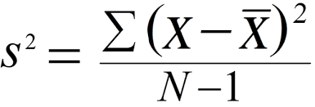

Standard Deviation: sqrt(S2)

### Measure Co-variance of security

Covariance measures the direction of the relationship between two variables. A positive covariance means that both variables tend to be high or low at the same time. A negative covariance means that when one variable is high, the other tends to below.

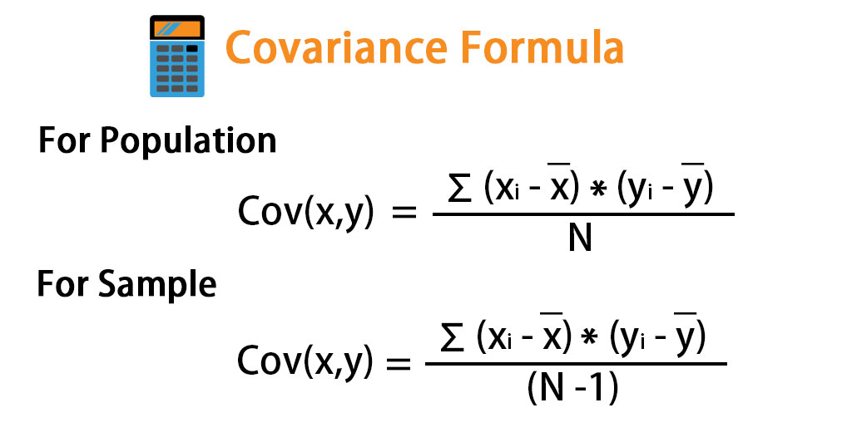

### Measure the Correlation Between Stocks

The correlation coefficient formula determines the relationship between two variables in a dataset and thus checks for the exactness between the predicted and actual values.

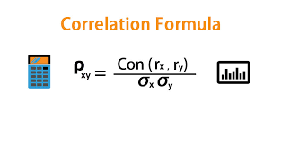

Pxy > 0 Two variable moves in the same direction

Pxy < 0 Two variable moves in the opposite direction

Pxy = 0 Two variable are independent

### Markowitz Portfolio Theory

* The objective of every rational investor is to maximise his returns and minimise the risk!
* Diversification is the method adopted for reducing risk. It essentially results in the construction of portfolios.
* The proper goal of portfolio construction would be to generate a portfolio that provide the highest return and the lowest risk.
* Such a portfolio would be known as the optimal portfolio.
* The process of finding the optimal portfolio is described as portfolio selection.

The conceptual framework and analytical tools for determining the optimal portfolio have been provided by Harry Markowitz His method of portfolio selection has come to be known as the Markowitz model. In fact, Markowitz's work marks the beginning of what is known today, as modern portfolio theory

**FEASIBLE SET OF PORTFOLIOS**

* With a limited number of securities an investor can create a very large number of portfolios by combining these securities in different proportions.
* These constitute the feasible set of portfolios in which the investor can possibly invest. This is also known as the portfolio opportunity set.
* Each portfolio in the opportunity set is characterised by an expected return and a measure of risk, viz., variance or standard deviation of returns.
* Not every portfolio in the portfolio opportunity set is of interest to an investor.
* A portfolio will dominate another if it has either a lower standard deviation and the same expected return as the other, or a higher expected return and the same standard deviation as the other. Portfolios that are dominated by other portfolios are known as inefficient portfolios.
* An investor would not be interested in all the portfolios in the opportunity set. He would be interested only in the efficient portfolios.

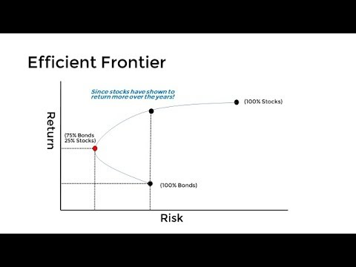

**SELECTION OF OPTIMAL PORTFOLIO**

* The portfolio selection problem is really the process of delineating the efficient  portfolios and then selecting the best portfolio from the set.
* Rational investors will obviously prefer to invest in the efficient portfolios.  The  particular portfolio that an individual investor will select from the efficient frontier  will depend on that investor's degree of aversion to risk.
* A highly risk averse investor will hold a portfolio on the lower left hand segment of  the efficient frontier, while an investor who is not too riskaverse will hold one on the upper portion of the efficient frontier.
* The selection of the optimal portfolio thus depends on the investor's risk aversion, or conversely on his risk tolerance.
* This can be graphically represented through a series of risk utility curves or indifference curves.
* Each curve represents different combinations of risk and return all of which are equally satisfactory to the concerned investor. The investor is indifferent between the successive points in the curve. Each successive curve moving upwards to the left represents a higher level of satisfaction or utility.

### Capital Asset Pricing Model

The Capital Asset Pricing Model (CAPM) describes the relationship between [systematic risk](https://www.investopedia.com/terms/s/systematicrisk.asp), or the general perils of investing, and [expected return](https://www.investopedia.com/terms/e/expectedreturn.asp) for assets, particularly stocks.1 It is a finance model that establishes a linear relationship between the required return on an investment and risk. The model is based on the relationship between an asset's [beta](https://www.investopedia.com/terms/b/beta.asp), the [risk-free rate](https://www.investopedia.com/terms/r/risk-freerate.asp) (typically the [Treasury bill](https://www.investopedia.com/terms/t/treasurybill.asp) rate), and the equity risk premium, or the expected return on the market minus the risk-free rate.

CAPM evolved as a way to measure this systematic risk. It is widely used throughout finance for pricing risky [securities](https://www.investopedia.com/terms/s/security.asp) and generating expected returns for assets, given the risk of those assets and [cost of capital](https://www.investopedia.com/terms/c/costofcapital.asp).

​***ERi* ​=*Rf*​+*βi*​(*ERm*​−*Rf*​)**

*where:*

*ERi*​ = expected return of investment

*Rf*​ = risk-free rate

*βi*​ = beta of the investment

(*ERm*​−*Rf*​) = market risk premium​

## 1.2 Objective of the study

* To learn about Python syntax, data types, operators, conditional statements, functions, lists, tuples, dictionaries, loops, arrays, learn how to import libraries and modules useful for doing financial analysis in Python.
* To see how to load and organize data and a crucial tool for any data analytical job.
* To learn about stock returns, risk, how to form investment portfolios, how to calculate the risk and return of investment portfolios, to calculate the correlation between financial securities and how to diversify a portfolio.
* To cover Markowitz Efficient Frontier analysis and learn how to verify if a portfolio lies in the efficient frontier.
* To learn the stock's beta and how it influences the desired rate of return from investors and how to apply the CAPM in practice.

## 1.3 Need and scope of the family

* Python is an ideal programming language for the financial industry. Widespread across the investment banking and hedge fund industries, banks are using Python to solve quantitative problems for pricing, trade management, and risk management platforms.
* Python also seems to have answers to most challenges raised by the financial industry when looking at analytics, regulation, compliance, and data, which are made easy by the abundance of supporting libraries.
* The rise of real-time analytics
* Helps to reduce the error rate at the time of designing the products for a complex industry like finance.
* Python provides less required code and quicker deployment which lets companies to market their products in a much faster way without having to dig into expensive resources.

## 1.4 Limitations of the study

* The secondary data collected might consist of manipulations, which might have given the bias in the result.
* The lack of experience in preparing the project report.
* Lack of time for completion of the project
* It is very difficult to check the accuracy of the information provided.
* I have Limited availability of technical talent or knowledge about these topics due to which I face many problems.

# 2. Company profile

Indev Consultancy Pvt. Ltd. (Indev), has 10+ years of experience in delivering cutting-edge ideas and solutions for development projects. Indev aims to leverage Information and Communication Technologies (ICTs) for Development. It has been developing technology products and solutions for various development interventions which are being implemented with government, UN agencies, Private entities, CSR programs, and Not-for-profit organizations.

Indev has delivered more than 100 successful projects in the development sector in the last 10 years contributing to human development by using appropriate and relevant technologies. We have been working in sectors such as Agriculture, Knowledge Management, Health, Nutrition, Education, and Governance, and successfully implemented these projects in partnership with the government.

With our expertise in a wide range of ICT tools and technologies, we have demonstrated our capability in the following technologies:

* Open Source (Linux, Apache, MYSQL, and PHP)
* E-Learning Module
* Analytics and DASHBOARD
* Mobile Platform (Android, SQLite, and JSON based data transfer)
* Database in specific (PostgreSQL, MYSQL, MS SQL)
* Design, Development & Maintenance of Website (Multiple Languages)
* Mobile Application Development
* Dedicated/VPS/ Cloud server administration

Our Programme areas are as follows:

Indev has been working with the **Dept. of Drinking Water and Sanitation, Govt. of India, ICDS Dept., TERI, Government of Maharashtra, UNDP, WHO, World Bank, ICRISAT, Save the Children, JSW Foundation, Jubilant Bhartia Foundation, NSDC,** and many others**.**

Our team is well equipped with Web Development Experts that includes web developer, web designer, graphics designer, online security expert and content editor, language experts.

**Our Website:** <http://indevconsultancy.com/>

### OUR USP

Indev Consultancy Pvt. Ltd. (Indev), has 10+ years of experience in delivering cutting-edge ideas and solutions for development projects government, UN agencies, Private entities, CSR programs, and Not- for-profit organizations.

Our USPs are:

* **Different Verticals:** Indev has extensive working experience in multiple domains like Web Development, Mobile Application Development, Digital Marketing, IoT, Research and Survey works.
* **Our Team:** We have a very well equipped and experienced team that helps us to provide standard products to our clients. Our team includes web developer, web designer, graphics designer, online security expert and content editor, language experts (Hindi, Bengali, English, and Assamese), Digital Marketing experts.
* **Physical Presence:** Indev has its presence in different areas of India. We have 8 offices in total: Head office in Delhi, 1 branch office in Sambalpur, Odisha and 6 local offices in Maharashtra. Apart from these we have our presence in Bengal, Assam, Bihar, and Chhattisgarh as well.
* **Team Strength:** Indev has a team of 210 full time employees working in Maharashtra and 45 people working in Delhi and Sambalpur office.
* **Professional Experience:** Indev has been working with the Dept. of Drinking Water and Sanitation, Govt. of India; ICDS Dept., Government of Maharashtra; UNDP; WHO; World Bank; Save the Children; JSW Foundation; Jubilant Bhartia Foundation; NSDC; ICRISAT and many others.
* **Expertise in Health domain:** Indev has grown an extensive experience in working in Health sector. We have been working with pregnant women, adolescent girls, and children below the age of 5 years.
* **Inhouse Development:** We have the strength and capacity to develop our own inhouse products. We have developed our IVR System, Heat Sensor, and many other IOT products.
* **Ethics & Culture:** In Indev, we not only develop web-based and mobile solutions; we also take care of implementation and end-to-end support and services. We believe in providing end to end support to our clients.

### Capability statement

Indev Consultancy Pvt. Ltd. (Indev), has 10+ years of experience in delivering cutting-edge ideas and solutions for development projects. Indev aims to leverage Information and Communication Technologies (ICTs) for Development. It has been developing technology products and solutions for various development interventions which are being implemented with government, UN agencies, Private entities, CSR programs, and Not-for-profit organizations.

For the last few years, Indev has successfully marked its footsteps in the field of Climate Change, Water Sanitation, and Knowledge Management. Various projects in collaboration with government and private entities have been implemented on survey and capacity building on sanitation, climate change control and precautions and behavioral change. Numerous websites have been designed and developed on Knowledge Management, these web platforms consist of informative videos, blogs, research papers etc.

We have also worked with the Dept. of Drinking Water and Sanitation, Govt. of India in their initiative for Swachh Bharat Mission, a Clean India programme specially planned for rural India. The programme target to provide access to sanitation facilities, understanding and knowledge improvement on clean surroundings and Solid & Liquid waste management.

Indev has been working with the Dept. of Drinking Water and Sanitation, Govt. of India; ICDS Dept., Government of Maharashtra; UNDP; WHO; World Bank; Save the Children; JSW Foundation; Jubilant Bhartia Foundation; NSDC and many others.

## 2.1 History of the company

### Some of our partners

|  |  |  |  |
| --- | --- | --- | --- |
| **Sr. No.** | **Name of the Organization** | **Duration of Engagement** | **Engagement Type** |
| 1 | JSW Foundation | 2016-2020 (till date) | Strengthen nutrition monitoring using innovative app-based tools for real-time monitoring to promote growth and behavior change in the family |
| 2 | Idea Vodafone CSR | 2018-2019 | Development of a mobile-based application and a web application for consistent monitoring of children, adolescent girls, pregnant and lactating women |
| 3 | Jubilant Bhartiya Foundation | 2018-2020 (till date) | Working together to ensure sustainability in the education path for all the youth, Health management and Nutrition Monitoring system |
| 4 | UNDP | 2018-2020 (till date) | Development of mobile-web based application which is a knowledge repository for entrepreneurs as well as a medium for them to connect to the buyers. |
| 5 | TINI | 2018-2019 | Development of Web and Mobile Based Solutions to monitor growth and Behavior change communication with the family. |
| 6 | Smile Foundation | 2019 – 2020 (till date) | collaborated for Nutrition Enhancement Program through developing mobile and web-based application |
| 7 | Save The Children | 2016-2019 | Development of a knowledge-based app with a motive to eliminate Diarrhoea from the world of diseases by 2020 |
| 8 | ICRISAT | 2018-2020 (till date) | To educate farmers to stay aware of fast-moving developments in technology, science, and an array of other skills and fields that affect agricultural operations |
| 9 | Shine Foundation | 2019 | Development of Mobile and Web application to track all activities held in school |
| 10 | FXB India | 2016-2020 (till date) | Design and maintenance of website |
| 11 | Language and Learning Foundation | 2016-2019 | Development of an Online Classroom where students can access reading materials and can chat with their mentors |
| 12 | Development News | 2017 – 2020 (till date) | Development of website for Online news |
| 13 | ARZ | 2016-2020 (till date) | Website development on Stop Trafficking |
| 14 | Kaushalya Foundation | 2018-2019 | Development of mobile and web-based application in providing a sustainable source of livelihood to the farmers |
| 15 | Sri Sai Netralaya | 2018-2019 | Development of ICT based solution for better eye care solutions |
| 16 | CRA India | 2019-2020 (till date) | Development of Audio Databook |
| 17 | NSDC | 2019 -2020 (till date) | Development of Knowledge portal to promote skill development |
| 18 | TERI | 2019 – 2020 (till date) | Development of a Flood Warning System |
| 19 | IPSA Labs | 2017 | Development of E-commerce platform |
| 20 | World Bank | 2019-2020 (till date) | Development and maintenance of website |
| 21 | TTC | 2018 – 2020 (till date) | Development of Web-Dashboard & Mobile Application for Adolescent Health and Midwifery Initiative |
| 22 | Britannia Foundation | 2019-2020 (till date) | collaborated for Nutrition Enhancement Program through developing mobile and web-based application |

# 3. Research methodology

## 3.1 Research Design

My project design will be descriptive followed by partially exploratory because the entire project will be based on the data collected from the internet, reports, Yahoo finance, journals, and analysis the detailed and clear description will be their in the project, so there is a mix of explanation and description design. It will cover all the major information and will give a clearer view to the reader how it works.

**Source Of Data**

The main sources of information in my project will be based on secondary data like facts, financial data, closing price of stocks, figures, graphs collected from internet, which will be analysed and summarized in the form of this project report.

My project topic basically falls in the category of python, finance, Investing and data analytics

## 3.2 Statistical tool used

* Work with scientific packages, like “NumPy”
* To use the data analysis toolkit, “Pandas”
* Plot graphs with “Matplotlib”
* Use “Python” to solve real-world tasks

### Numpy

Numpy is an array processing package that can be used for a variety of tasks. It offers high-performance multidimensional array objects as well as array-related tools. The homogeneous multidimensional array is NumPy's core object. It's a table containing the same datatype elements or numbers, indexed by a tuple of positive integers.

What can you do with NumPy?

Basic array operations: add, multiply, slice, flatten, reshape, index arrays

Advanced array operations: stack arrays split into sections, broadcast arrays

Work with DateTime or Linear Algebra

Basic Slicing and Advanced Indexing in NumPy Python

### Pandas

Pandas is a Python library that provides high-performance, easy-to-use data structures, and data analysis tools for labeled data. Python Data Analysis Library is referred to as Pandas. Pandas take data from a CSV or TSV file or a SQL database and turn it into a data frame, a Python object with rows and columns.

### Matplotlib

Matplotlib is a Python plotting library that offers an object-oriented API for embedding plots in applications. It is similar to MATLAB embedded in the Python programming language. Matplotlib can display a wide range of visualizations, including histograms, bar plots, scatter plots, area plots, and pie plots. With a bit of effort and tint of visualization capabilities, with Matplotlib, you can create just any visualizations:

* Line plots
* Scatter plots
* Area plots
* Bar charts and Histograms
* Pie charts
* Stem plots
* Contour plots
* Quiver plots
* Spectrograms

# 4. Data analysis and interpretation

### Calculate a security’s rate of return in python – Simple Return

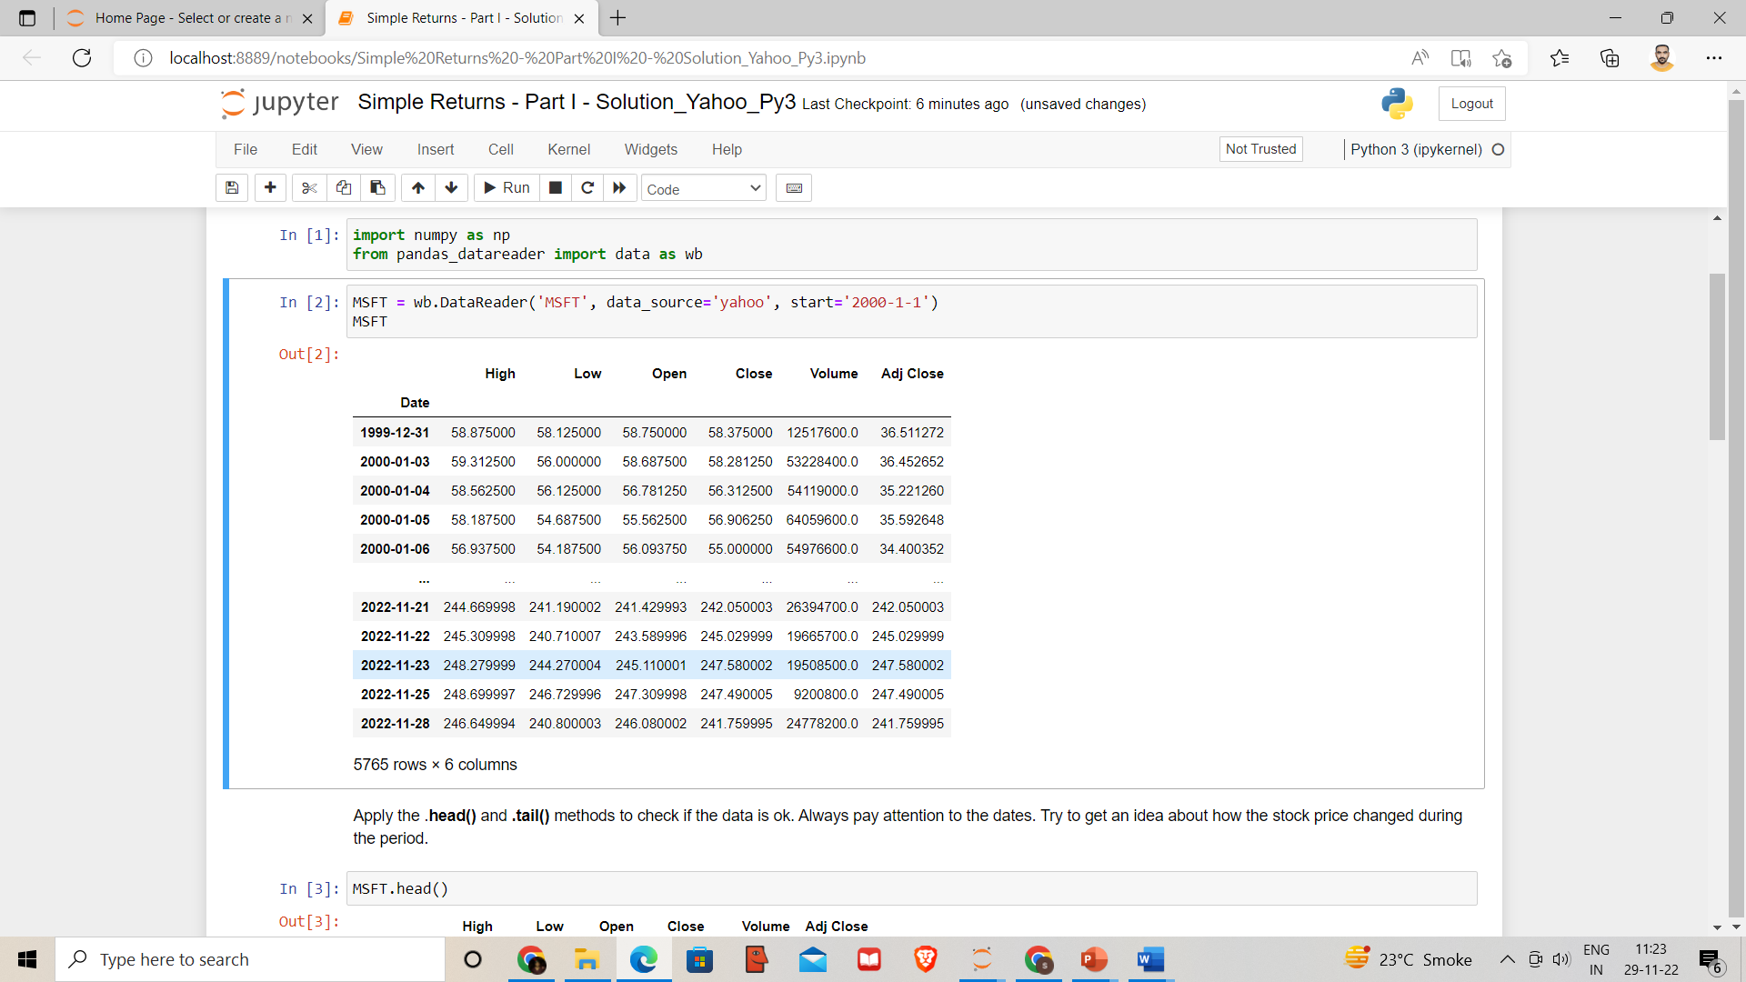Data for Microsoft(‘MSFT’) from Yahoo Finance for the period ‘2000-1-1’ until today.

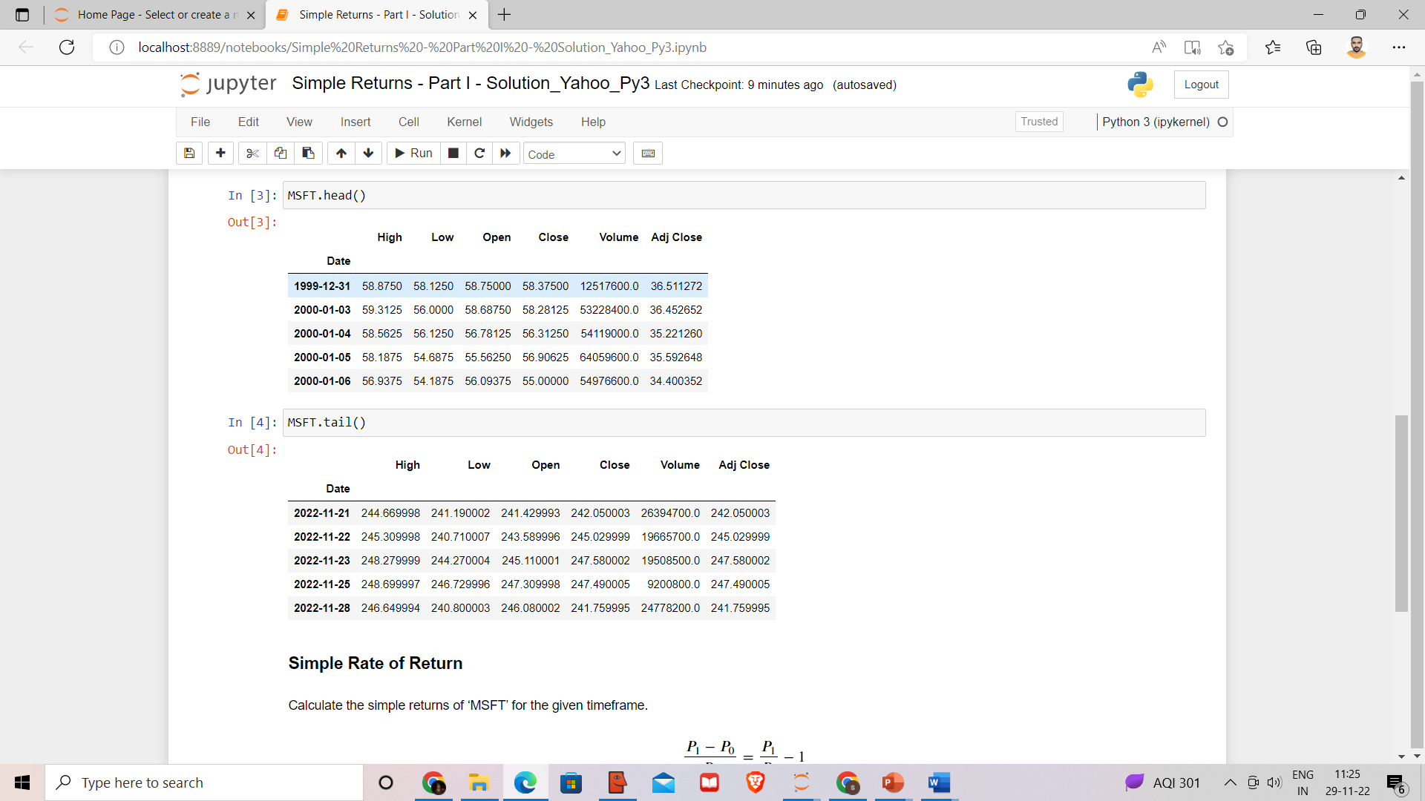

The simple returns of ‘MSFT’ for the given timeframe:

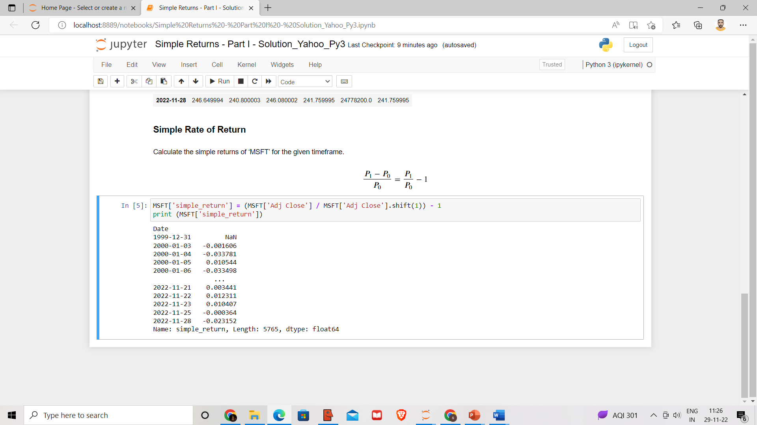

**Interpretation:**

Results on the graph

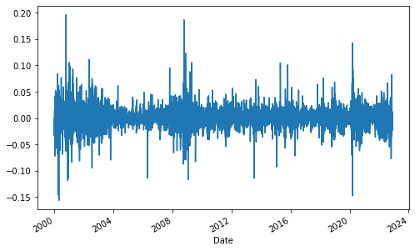

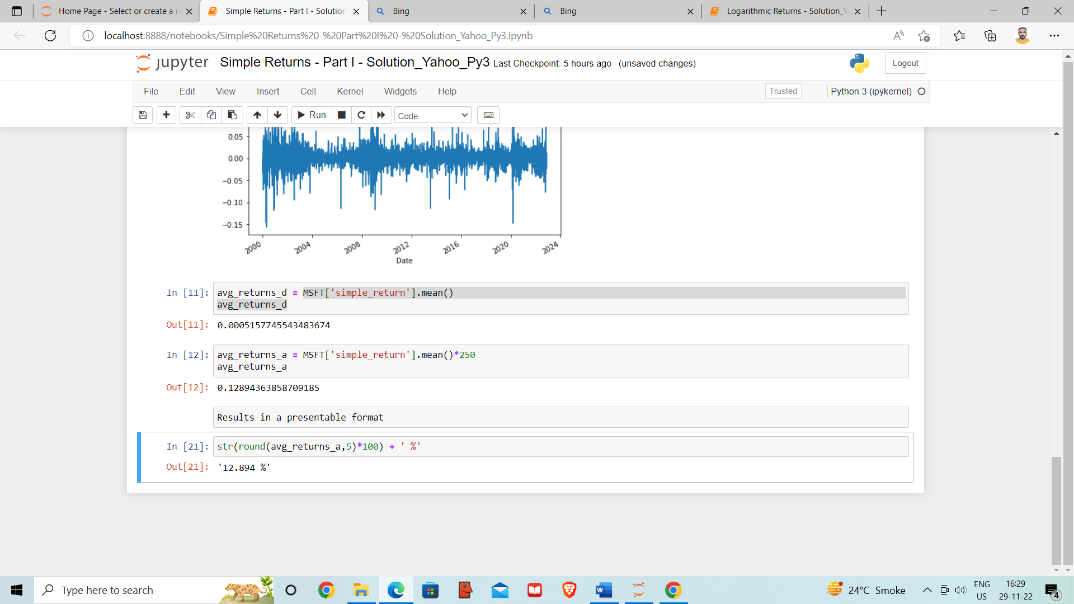Estimation of the daily and annual mean of simple return

### Calculating a security’s rate of return in python – Logarithmic Return

Data for Microsoft(‘MSFT’) from Yahoo Finance for the period ‘2000-1-1’ until today.

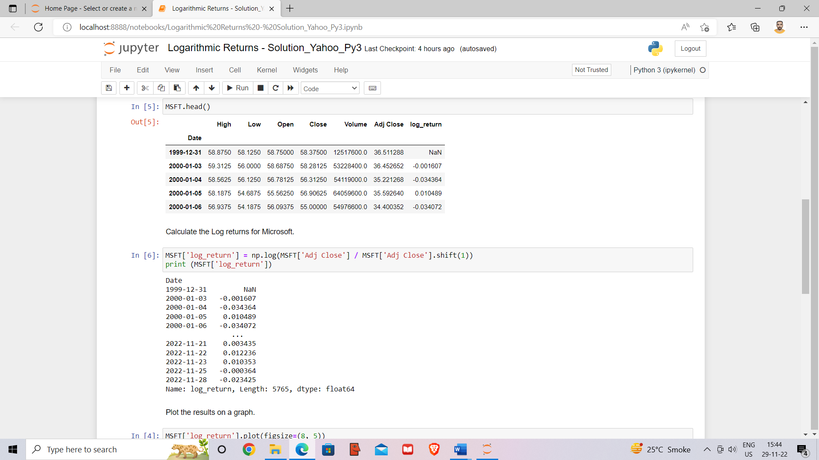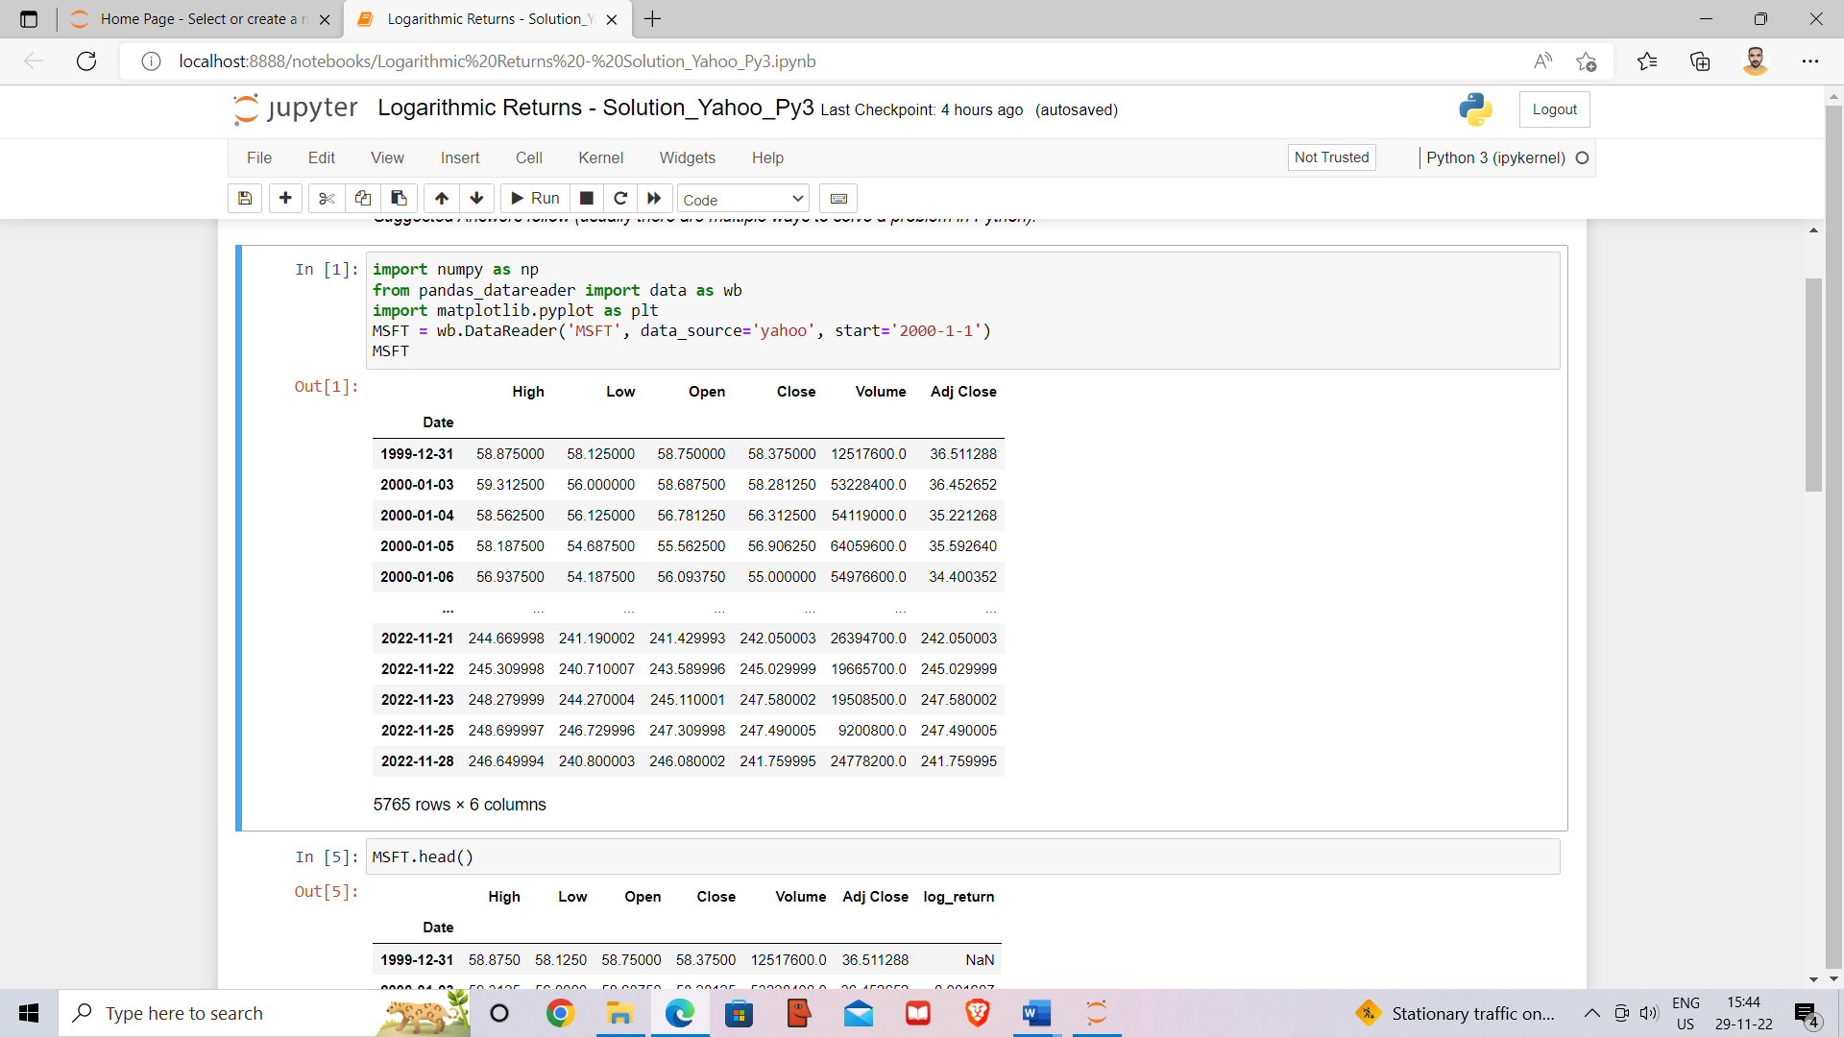

**Interpretation:**

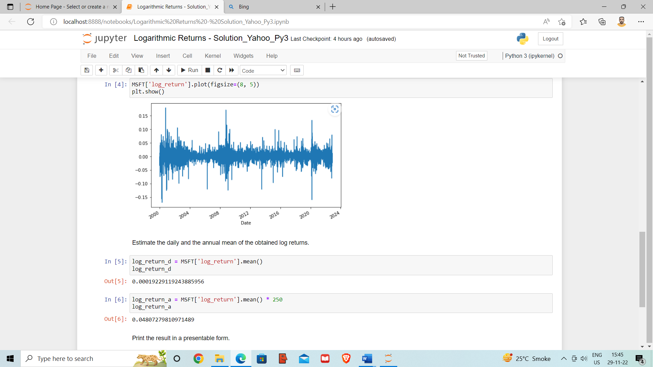Results on the graph

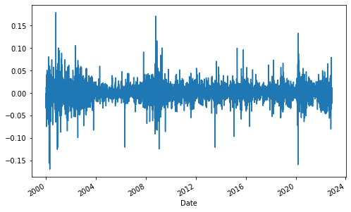

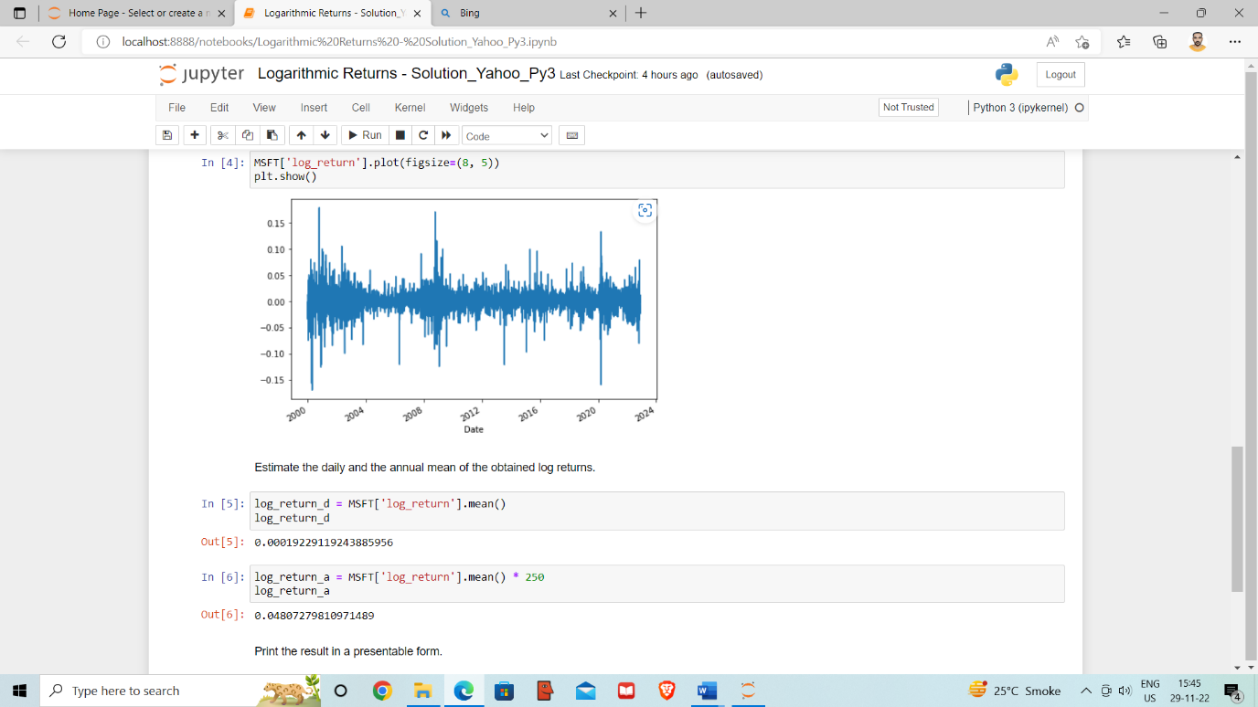Estimation of the daily and annual mean of obtained log return

Results in a presentable format

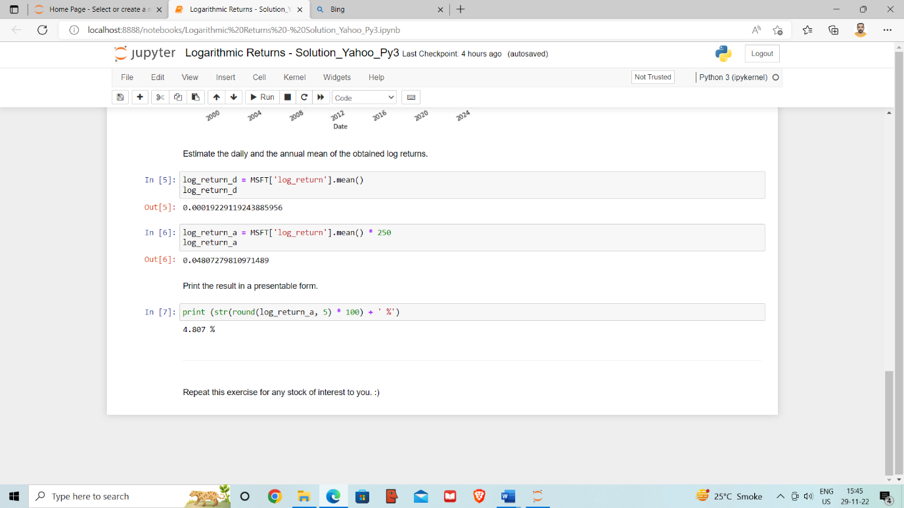

### Calculate the Indices Rate of Return

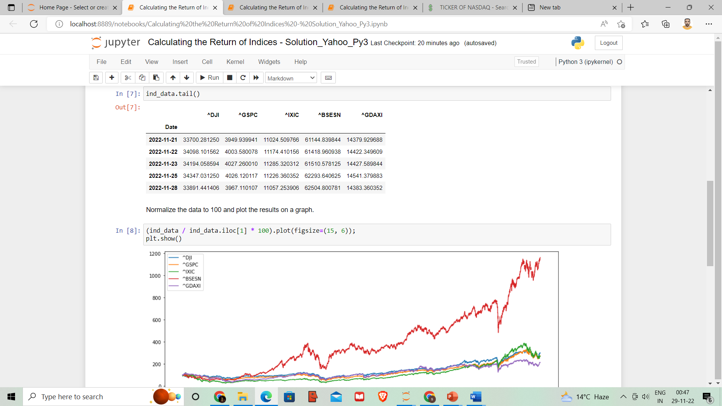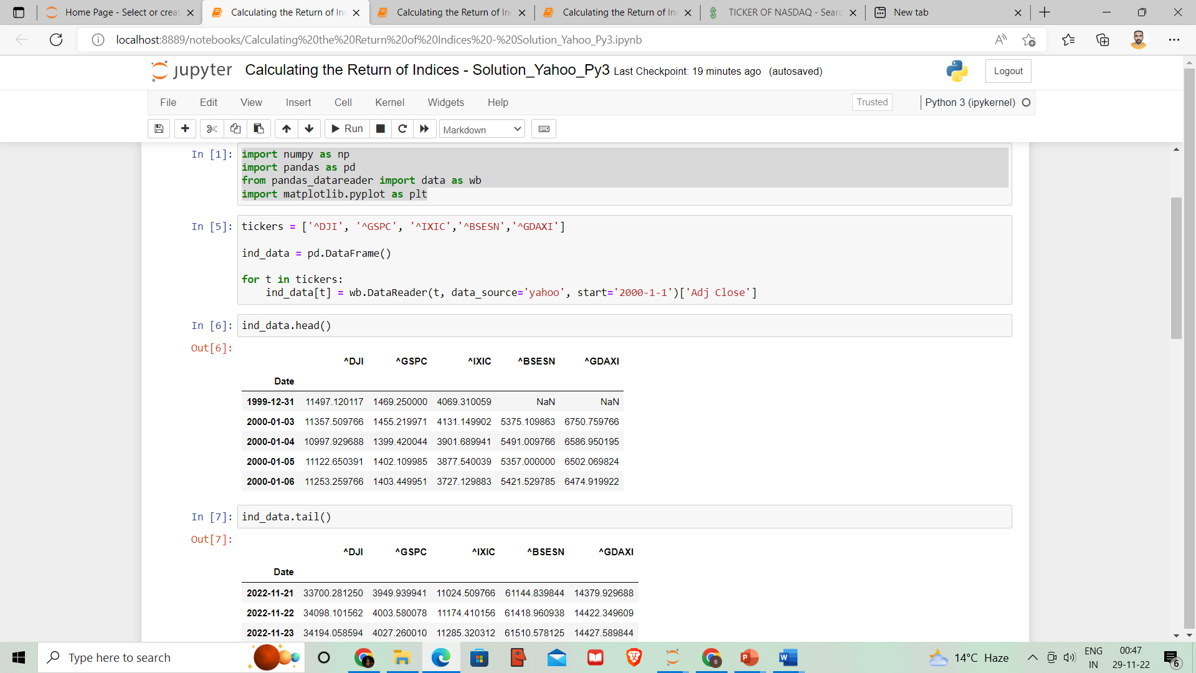Consider famous market indices – Dow Jones, S&P 500, the Nasdaq, Bombay Stock Exchange, and German Dax for the period of 1st of January 2000 until today.

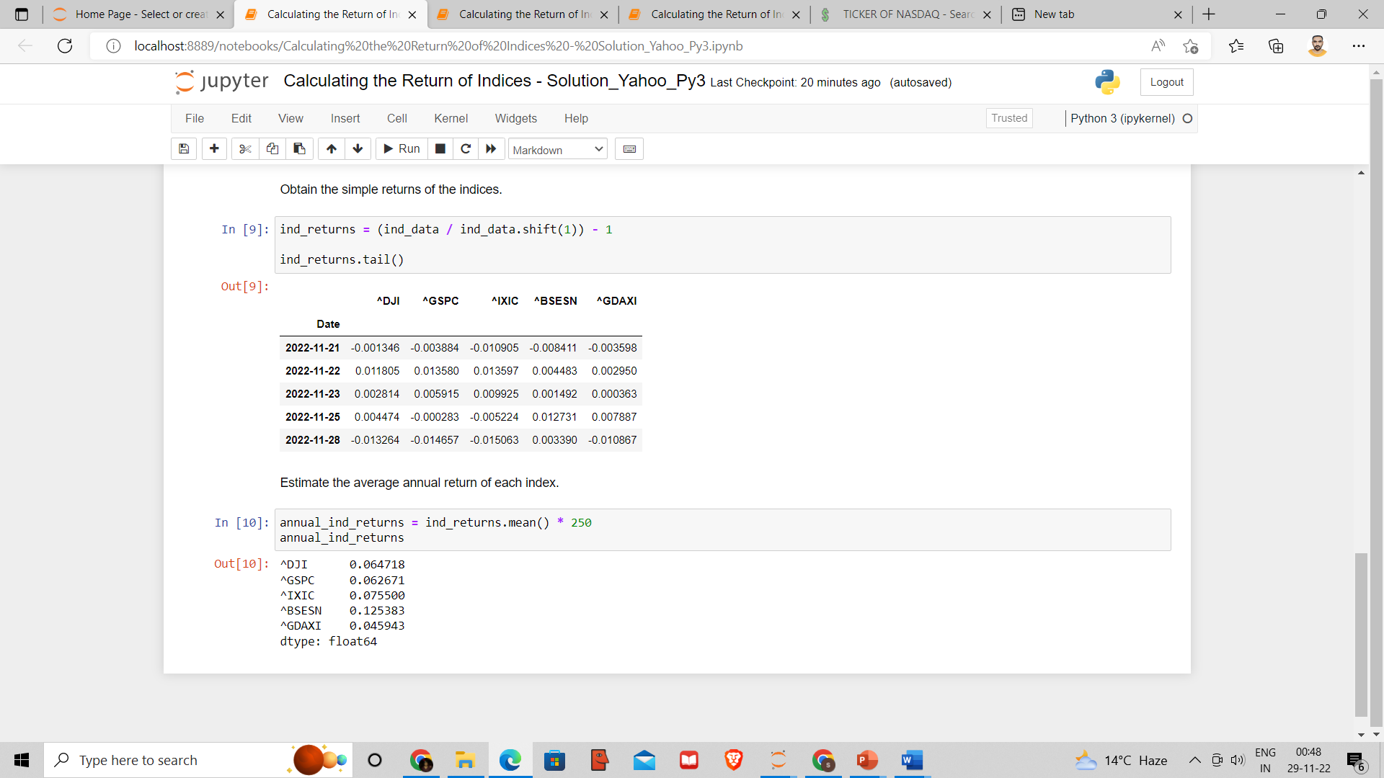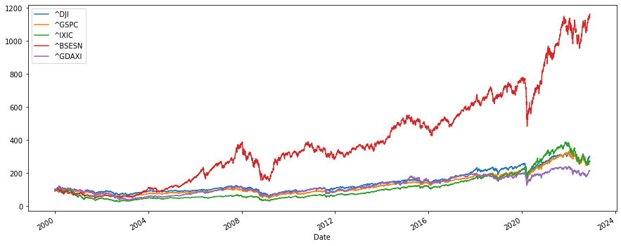

**Interpretation:**

The average annual return of each index is as follows



Bombay Stock Exchange has given maximum average annual returns = 12.54%

### Obtain the Efficient Frontier

Extracting data for Walmart, Facebook, and British Petroleum from the 1st of January 2014 until today.

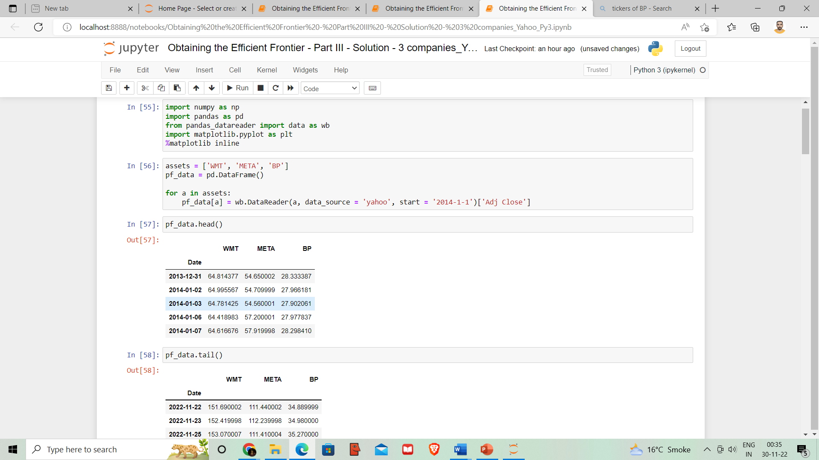

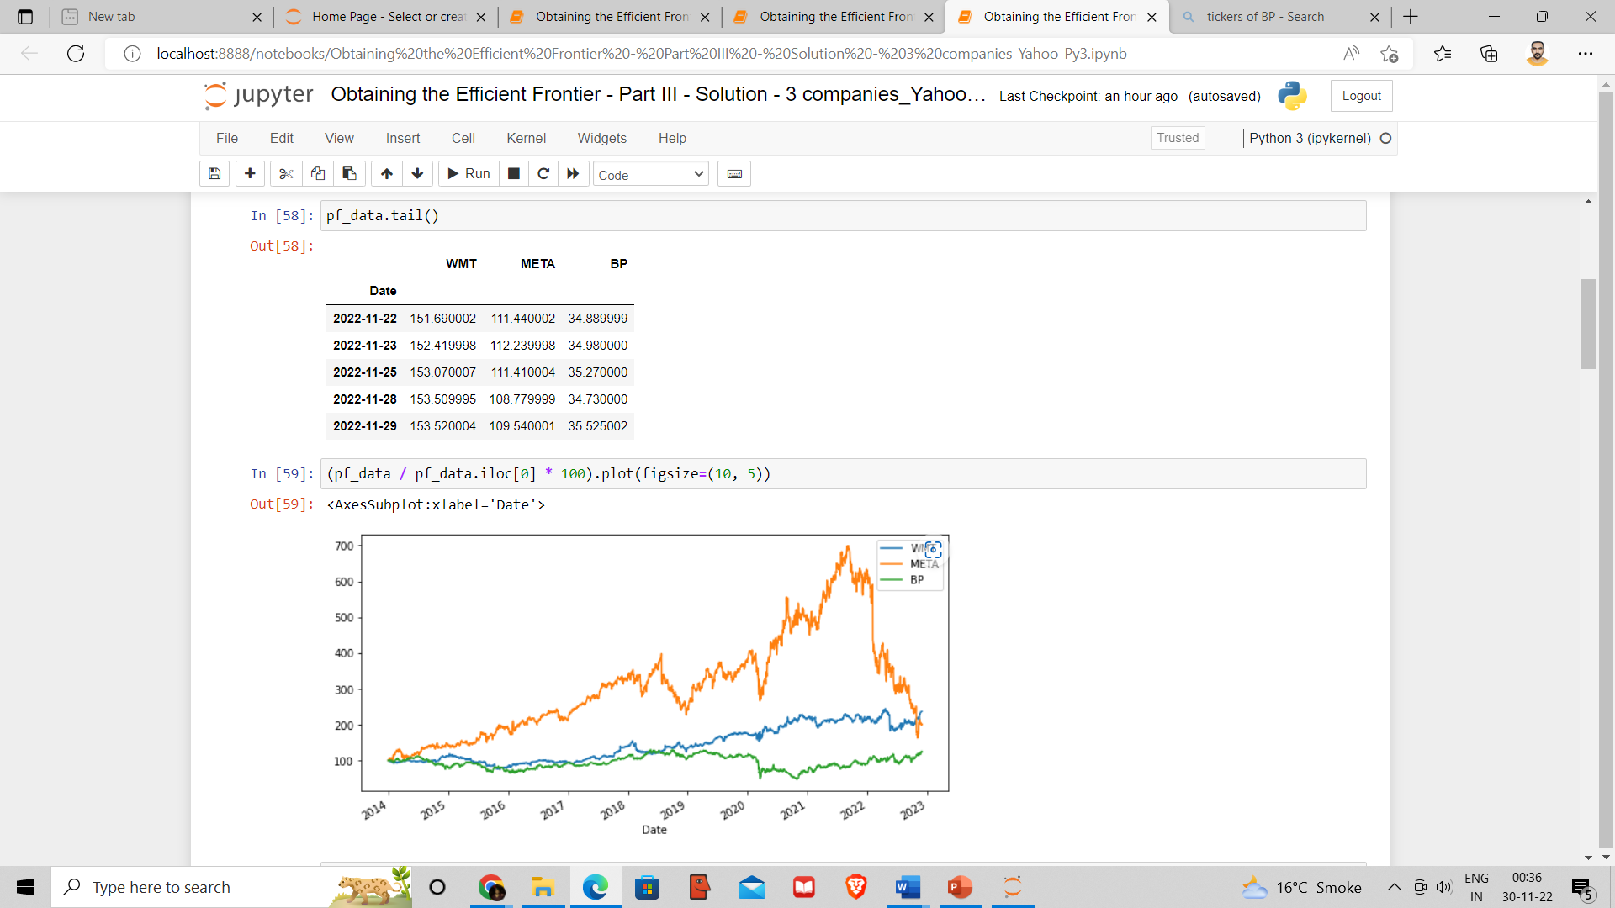

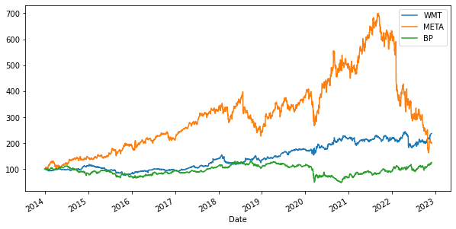

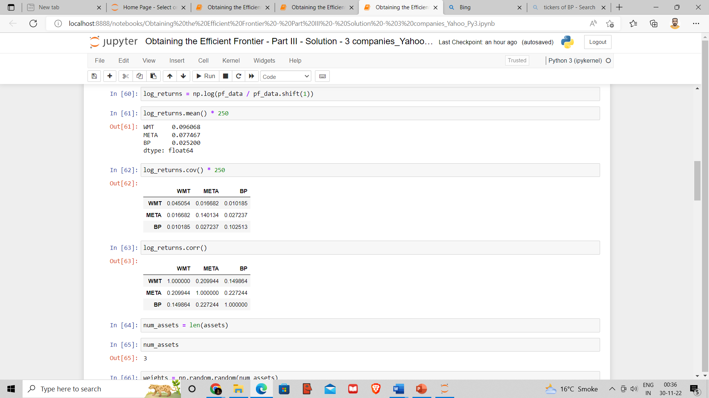

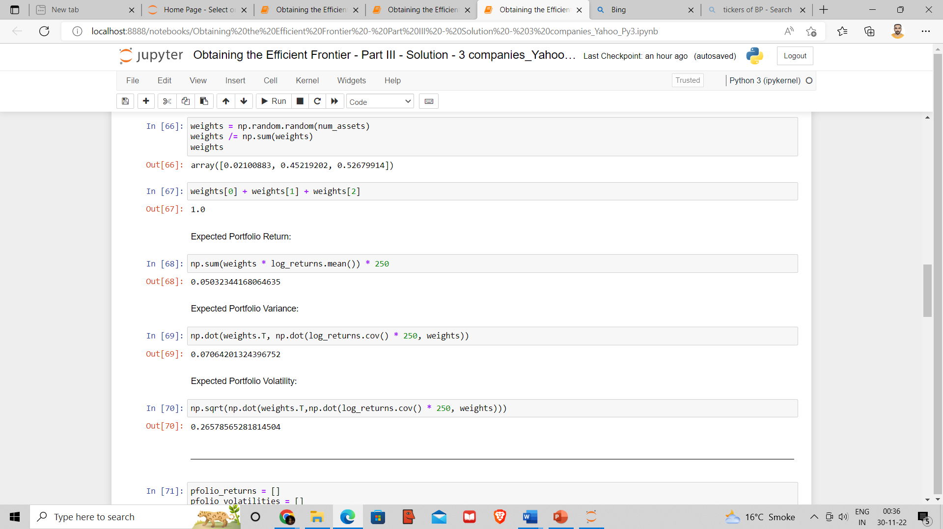

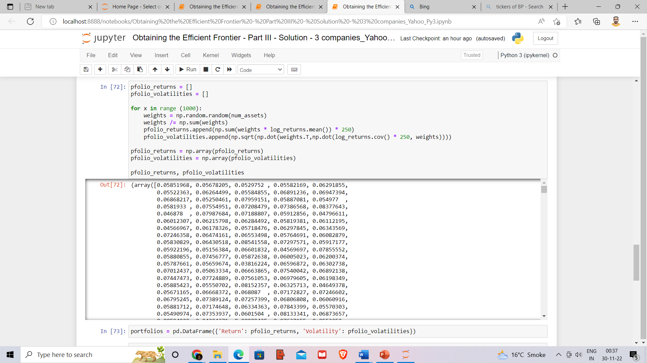

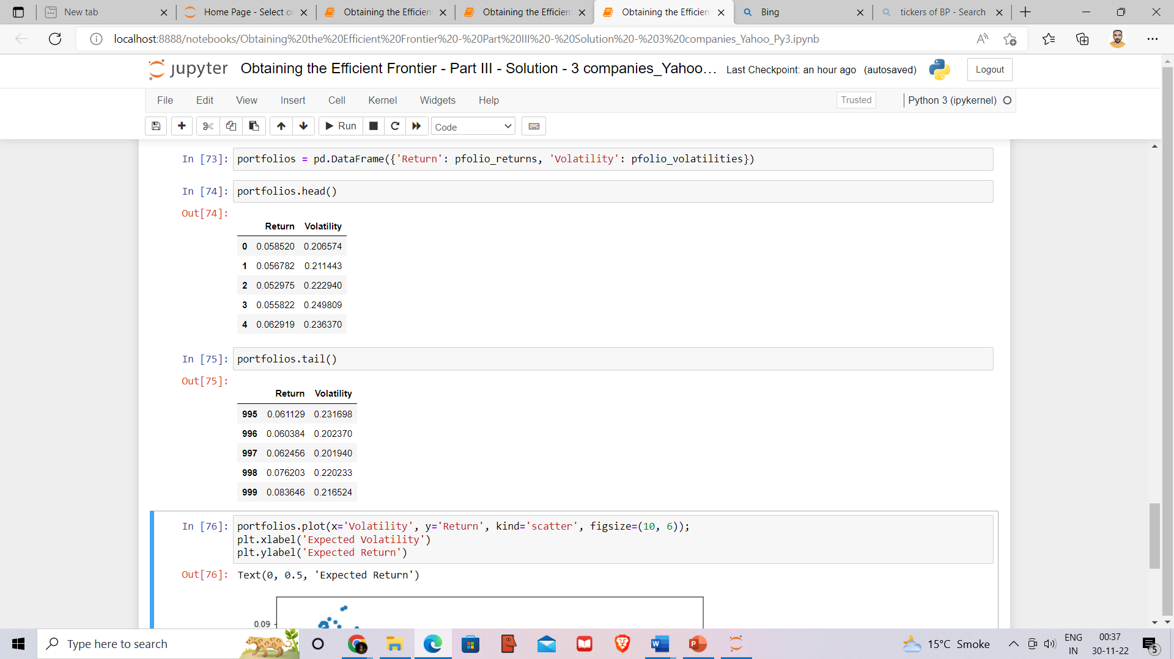

**Interpretation:**

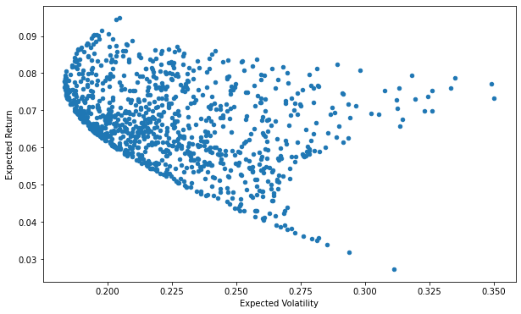

### Calculate Beta and Expected return of a Stock (CAPM)

Obtain data for Tata Consultancy Service and Nifty for the period 1st of January 2012 – 29th of November 2022 from Yahoo Finance. Let Nifty act as the market.

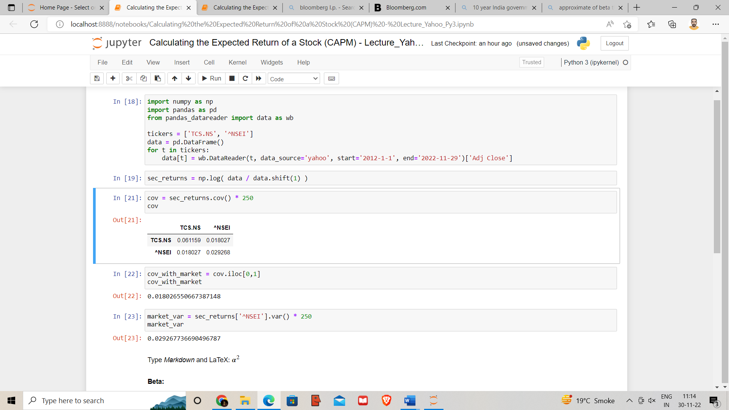

**Interpretation:**

Beta:

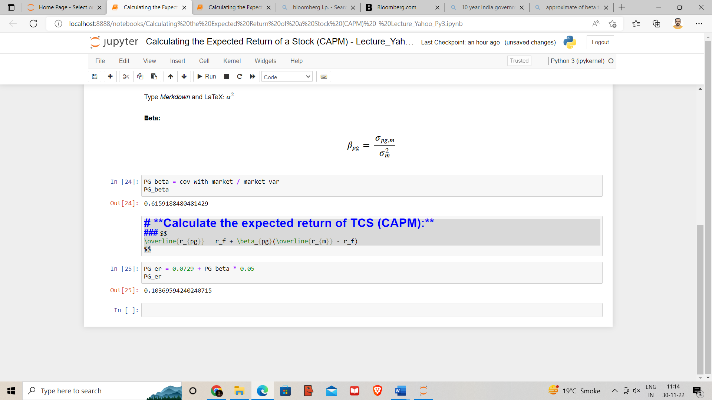

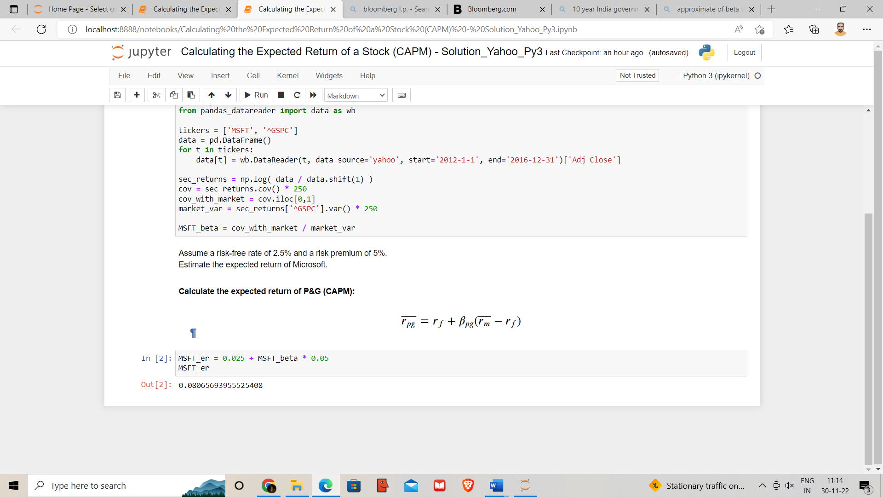The expected return:



### Estimate the Sharpe Ratio and verifying how good a portfolio manager is doing

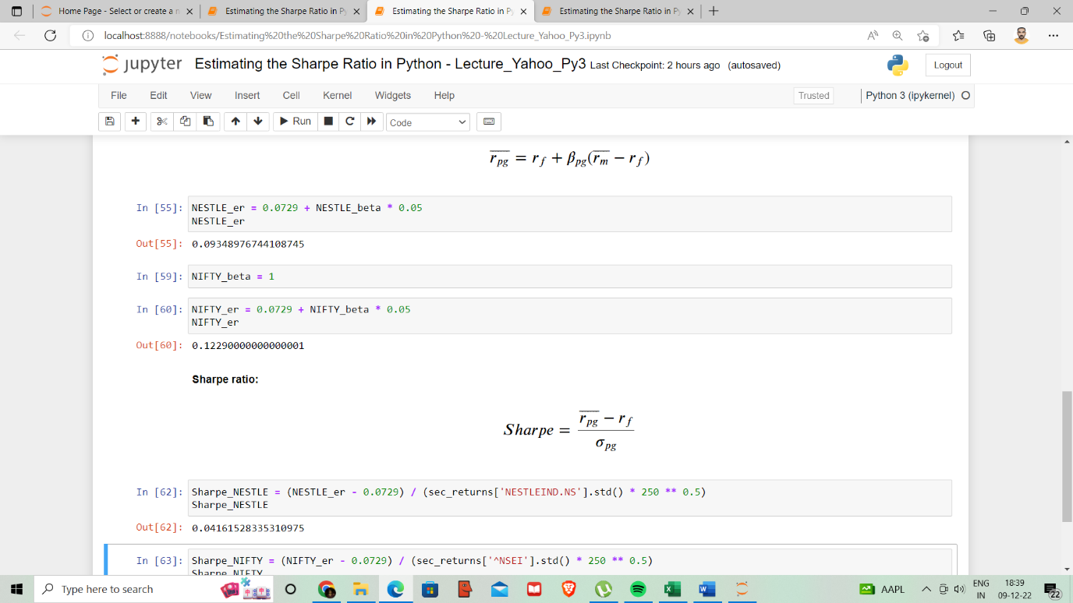

**Interpretation:**

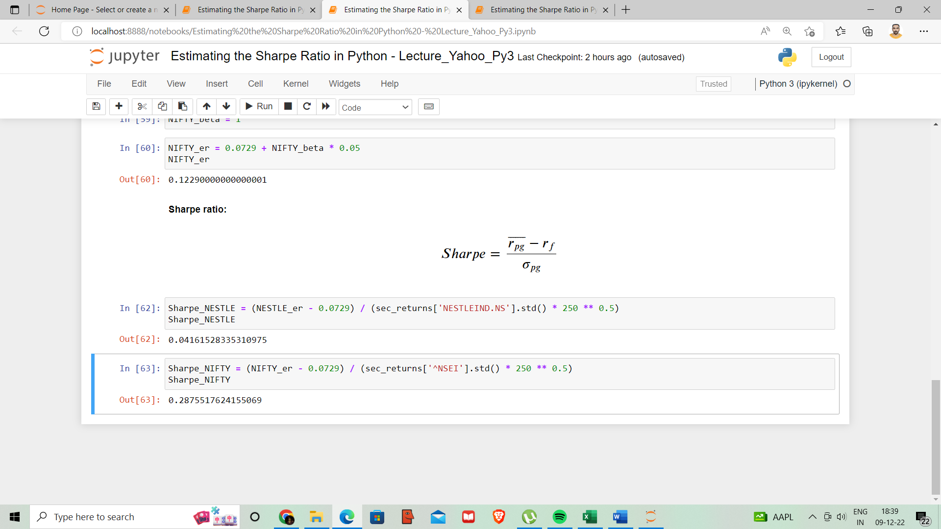

As per Sharpe’s performance measure Nestle has performed worse than the benchmark Nifty index

# 5. Conclusion

The financial industry is quickly evolving into a more technologically advanced ecosystem. As a result, banks and other financial firms now favour Python as the top language for developing trade, pricing, and risk management applications.

Python is without a doubt the greatest language for creating financial apps due to its clear and easy syntax, collaborative capabilities, environment stocked with libraries, and high-Level advantage.

Some of the largest financial/fintech companies, like Paypal, Stripe, Croodle, Vyze, Venmo, etc., use largely Python finance resources for their projects due to how widely used Python is for financial research.

## 5.1 Findings

* Famous market indices like Dow Jones, S&P 500, the Nasdaq, Bombay Stock Exchange, and German Dax for the period of 1st of January 2000 until today, Bombay stock exchanges has been beaten all the above Indices
* Sharpe ratio is more appropriate than treynor ratio for measuring risk adjusted return.
* To find risk free return, we should look for 10 years country’s bond yield.
* Optimal portfolios that comprise the efficient frontier usually exhibit a higher degree of diversification.
* Data for Tata Consultancy Service and Nifty for the period 1st of January 2012 – 29th of November 2022, TCS has more risk than Nifty.
* Data for Walmart, Facebook, and British Petroleum from the 1st of January 2014 until today, Walmart has more logarithmic annual return than above stocks.

## 5.2 Bibliography

* <https://finance.yahoo.com/>
* <https://training.gitbook.io/python-documents/>
* <https://www.morningstar.in/equities.aspx>
* Security Analysis and Portfolio Management (S.Kevin)
* <https://www.consoleflare.com/>
* Modern Portfolio Theory and Investment Analysis(4th ed., John Wiley & Sons, New York.)
* [Bloomberg.com](https://www.bloomberg.com/asia)